Assignment Description
For this assignment I have compiled a few example programs from the Boost library

1 Readme Documentation

2 Flowchart Screen Shots

3 UML and Use Case Diagrams

4 Source Code of All files (.h, .cpp)
Chrono_unit_test.cpp:
// chrono_unit_test.cpp ----------------------------------------------------//

// Copyright 2008 Beman Dawes

// Distributed under the Boost Software License, Version 1.0.
// See http://www.boost.org/LICENSE_1_0.txt

#define _CRT_SECURE_NO_WARNINGS // disable VC++ foolishness

#include <boost/chrono/chrono.hpp>
#include <iostream>

int main()
{
std::time_t sys_time
= boost::chrono::system_clock::to_time_t(boost::chrono::system_clock::now());

#ifdef UNDER_CE
// Windows CE does not define asctime()
struct tm * t = std::gmtime(&sys_time);
std::cout
<< "system_clock::to_time_t(system_clock::now()) is "
<< t->tm_mon << "/" << t->tm_mday << "/" << (1900 + t->tm_year) << " " << t->tm_hour << ":" << t->tm_min << ":" << t->tm_sec << std::endl;
#else
std::cout
<< "system_clock::to_time_t(system_clock::now()) is "
<< std::asctime(std::gmtime(&sys_time)) << std::endl;
#endif

return 0;
}

Credit_card_example.cpp:
/*
*
* Copyright (c) 1998-2002
* John Maddock
*
* Use, modification and distribution are subject to the
* Boost Software License, Version 1.0. (See accompanying file
* LICENSE_1_0.txt or copy at http://www.boost.org/LICENSE_1_0.txt)
*
*/

/*
* LOCATION: see http://www.boost.org for most recent version.
* FILE credit_card_example.cpp
* VERSION see <boost/version.hpp>
* DESCRIPTION: Credit card number formatting code.
*/

#include <boost/regex.hpp>
#include <string>

bool validate_card_format(const std::string& s)
{
static const boost::regex e("(\\d{4}[- ]){3}\\d{4}");
return boost::regex_match(s, e);
}

const boost::regex e("\\A(\\d{3,4})[- ]?(\\d{4})[- ]?(\\d{4})[- ]?(\\d{4})\\z");
const std::string machine_format("\\1\\2\\3\\4");
const std::string human_format("\\1-\\2-\\3-\\4");

std::string machine_readable_card_number(const std::string& s)
{
return boost::regex_replace(s, e, machine_format, boost::match_default | boost::format_sed);
}

std::string human_readable_card_number(const std::string& s)
{
return boost::regex_replace(s, e, human_format, boost::match_default | boost::format_sed);
}

#include <iostream>
using namespace std;

int main()
{
string s[4] = { "0000111122223333", "0000 1111 2222 3333",
"0000-1111-2222-3333", "000-1111-2222-3333", };
int i;
for(i = 0; i < 4; ++i)
{
cout << "validate_card_format(\"" << s[i] << "\") returned " << validate_card_format(s[i]) << endl;
}
for(i = 0; i < 4; ++i)
{
cout << "machine_readable_card_number(\"" << s[i] << "\") returned " << machine_readable_card_number(s[i]) << endl;
}
for(i = 0; i < 4; ++i)
{
cout << "human_readable_card_number(\"" << s[i] << "\") returned " << human_readable_card_number(s[i]) << endl;
}
return 0;
}

Timex.cpp:
// timex: timed execution program ------------------------------------------//

// Copyright Beman Dawes 2007

// Distributed under the Boost Software License, Version 1.0.
// See http://www.boost.org/LICENSE_1_0.txt

// See http://www.boost.org/libs/timer for documentation.

#include <boost/timer/timer.hpp>
#include <cstdlib>
#include <string>
#include <iostream>

int main( int argc, char * argv[] )
{
if ( argc == 1 )
{
std::cout << "invoke: timex [-v] command [args...]\n"
" command will be executed and timings displayed\n"
" -v option causes command and args to be displayed\n";
return 1;
}

std::string s;

bool verbose = false;
if ( argc > 1 && *argv[1] == '-' && *(argv[1]+1) == 'v' )
{
verbose = true;
++argv;
--argc;
}

for ( int i = 1; i < argc; ++i )
{
if ( i > 1 ) s += ' ';
s += argv[i];
}

if ( verbose )
{ std::cout << "command: \"" << s.c_str() << "\"\n"; }

boost::timer::auto_cpu_timer t(" %ws elapsed wall-clock time\n");

return std::system( s.c_str() );
}

Auto_cpu_timer_example.cpp
// auto_cpu_timer_example.cpp ------------------------------------------------------//

// Copyright Beman Dawes 2006

// Distributed under the Boost Software License, Version 1.0.
// See http://www.boost.org/LICENSE_1_0.txt

#include <boost/timer/timer.hpp>
#include <cmath>

int main()
{
boost::timer::auto_cpu_timer t;

for ( long i = 0; i < 100000000; ++i )
std::sqrt( 123.456L ); // burn some time

return 0;
}

5 Three Use Case Screen Shots
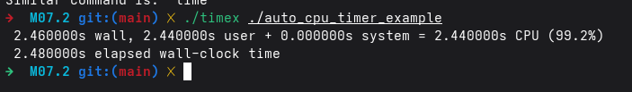

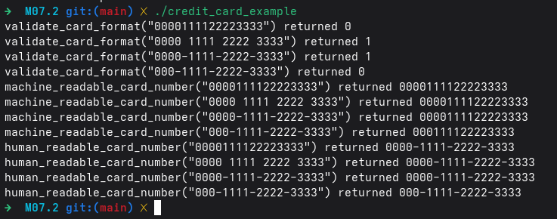

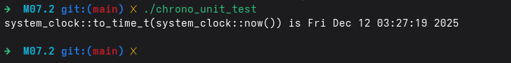

(Optional) GitHub URL

